CHAPTER SEVEN

IDENTIFYING AND REPORTING ABUSE

ABUSE OVERVIEW

A guardianship or a protective proceeding in which a guardian ad litem (GAL) has been appointed necessarily involves protection of an individual who may be vulnerable. A “vulnerable adult” is:

A person eighteen years of age or older who has a physical or mental condition which substantially impairs the person from adequately providing for his or her own care or protection. This includes a person who is impaired in the ability to adequately provide for the person’s own care or protection because of the infirmities of aging including, but not limited to organic brain damage, advanced age, and physical, mental, or emotional dysfunction. A resident of a facility is a vulnerable adult.

In these cases, a GAL should be alert to the potential for abuse, neglect, or exploitation. It is important for the GAL to know the signs of abuse, make appropriate investigation, be prepared to report to the court on this issue, and take the appropriate steps to protect the vulnerable individual. The goal of this chapter is to equip the GAL with tools to identify abuse and exploitation, and to inform the GAL as to when and where to report abuse.

WHAT IS ABUSE?

Lay people often think of abuse in terms of violence against an individual. Terms such as “domestic violence” perpetuate the concept of abuse as primarily physical in nature. While physical harm is a concern, abuse also includes any use of power and control as a means of gaining advantage of or dominance over another individual.

The “Duluth Power and Control Wheel” provides an excellent visual representation of the types of abuse. This wheel, created by the Domestic Intervention Programs of Duluth, MN, was the result of extensive research involving victims of abuse. The Duluth Power and Control Wheel places “power and control” at the center of a wheel with various manifestations of abuse shown as spokes emanating from that wheel. Refining this even further to the elderly population, the National Clearinghouse on Abuse in Later Life asked a group of vulnerable adults to share their experiences. The result is below.

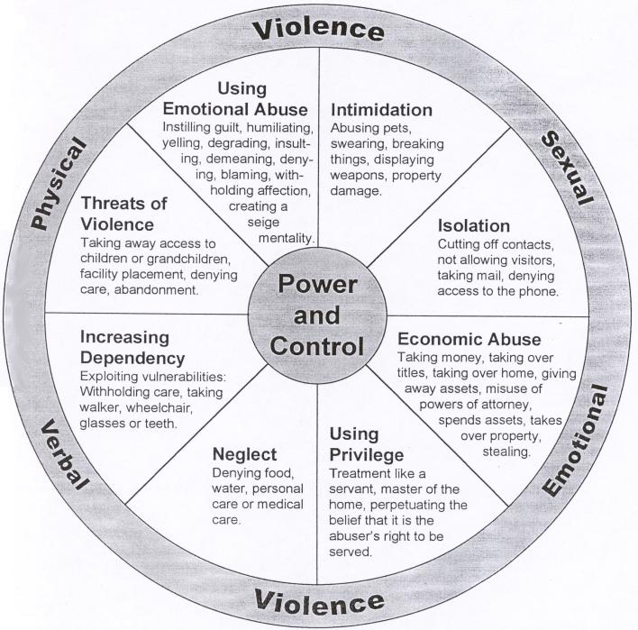

Additional definitions of abuse of vulnerable adults include:

- “An intentional act, or failure to act, by a caregiver or another person in a relationship involving an expectation of trust, that causes or creates a risk of harm to an older adult.”
- “Abuse, neglect, abandonment, or financial exploitation of an older individual by another person or entity who has a trust-based relationship with the older adult, or any harm that occurs because an older person is targeted by a stranger based on their age or disability.”
- “Physical, sexual, or psychological abuse, as well as neglect, abandonment, and financial exploitation of an older person by another person or entity, that occurs in any setting (e.g., home, community, or facility), either in a relationship where there is an expectation of trust and/or when an older person is targeted based on age or disability.”
- "A single or repeated act, or lack of appropriate action, occurring within any relationship where there is an expectation of trust, which causes harm or distress to an older person."

Some specific manifestations of abuse in the context of a vulnerable adult might include:

- Economic abuse (taking money or using it for the perpetrator’s benefit, transferring titles, taking over home, giving away assets, misusing powers of attorney, transferring property, stealing);
- Coercion (threatening to hurt the person, threatening to withhold needed support and leaving person unattended, pressuring the person to take some unwanted action);
- Threats (of taking away access to children or grandchildren, facility placement, denial of care, abandonment);
- Emotional abuse (guilt, humiliation, yelling, degrading or insulting or demeaning comments, withholding affection, creating a siege mentality);
- Intimidation (threatening gestures, abusing pets, swearing, breaking things, displaying weapons, damaging property);
- Isolation (cutting off contacts, not allowing visitors, taking mail, denying access to phone);
- Misuse of privilege (treating the person as a child or servant, making unilateral decisions, providing care in a way that accentuates the person’s dependence, denying the right to privacy);
- Withholding or delaying needed supports (using medication to sedate the person, ignoring equipment safety requirements, breaking or not fixing adaptive devices such as dentures or hearing aids, withdrawing care or equipment so as to immobilize the person, using equipment to inflict pain);
- Justification and blame (denying or making light of abuse, denying physical or emotional pain, justifying rules that limit autonomy or dignity);
- Neglect (denying food, water, personal or medical care).

The complexity of abuse of a vulnerable adult is compounded by several factors. In a situation involving an individual who is already vulnerable (whether by reason of physical frailty, mental incapacity, special dependence upon a caregiver or trusted individual or some other particular circumstance), the victim may have challenges communicating or even identifying the actions as abusive. The GAL will need to pay attention to signs and symptoms, conducting careful examination of medical charts and interviews with observers who have personal knowledge.

When an A.I.I. seems to be making poor decisions or has made gifts or seemingly inappropriate financial decisions, particular attention must also be paid to issues surrounding capacity and the possibility that someone may be taking advantage of that vulnerability. Factors relating to mental capacity include orientation as to place and time, short-term memory, long-term memory, verbal fluency and use of words, and attentiveness, and executive function. Simply put, executive function is more or less the capacity of the individual to understand all the consequences of their actions. As an example of how impaired executive function might make a person vulnerable to exploitation is the situation where a parent desires to make a monetary gift to their child. The parent might not fully comprehend, however, that if they make the gift, they might not have enough funds to finance their old age care. Detailed discussion of capacity is beyond the scope of this manual other than to note that if there are questions regarding capacity, these questions should be discussed more fully with the mental health experts involved in the case.

Additionally, abuse often occurs within the context of a family in which patterns of relationships are well established and complex (see hypothetical below). In a situation involving exploitation by a trusted family member, the vulnerable adult may not realize he or she is exploited. Or the vulnerable adult may understand that he or she is being abused but allows it to continue. A person exploiting a vulnerable adult may not realize his or her actions could be viewed as exploitation (for example, when a family member seeks a “family price” on sale of a house). The GAL must pay close attention to protecting the vulnerable adult from any repercussions that might result from the reporting.

Hypothetical: John is the adult child of eighty-six-year-old Sarah, with whom he has lived for many years. John is unemployed and suffers from mental illness and alcoholism, making it hard for him to live independently. John’s sister Carolyn believes John is taking advantage of Sarah by not sharing household expenses. On the other hand, John provides positive social interaction and caregiving support that has enabled the Sarah to remain in her own home. Carolyn has filed for guardianship and conservatorship. Has there been exploitation, or has the benefit to Sarah outweighed the cost of what she has given John? Should the situation be stopped? Are the family dynamics “normal” for this family, or are they hostile? Is there a danger to Sarah? To tease out the answer to questions of these types, it is important for a lay GAL to develop an understanding of the dynamics of family systems, as well as some of the concrete steps necessary to investigate and report to the court.

Use the following list to assist in identifying abusive situations. Keep in mind that this list is not comprehensive. The GAL should use his or her best judgment in evaluating the potential for abuse in any situation.

ISOLATION OF VULNERABLE ADULT
- Never leaves residence (due to agoraphobia, lack of transportation, health issues, etc.);
- Inadequate visits by caregiver(s);
- Lack of visitors;
- No alert device worn by adult;
- Self-neglect.
NEGLECT BY CAREGIVERS
(caregivers may be family, friends, employees, or neighbors)
- Lack of food/unpalatable food;
- Uncleanliness of home and person;
- Abandonment;
- Inability to properly administer medication.
SAFETY ISSUES
- Physical abuse;
- Domestic violence by partner;
- Sexual abuse;
- Mental/psychological abuse;
- Emotional abuse;
- Home environment that does not accommodate needs of adult (lack of accessible bathroom, presence of physical safety hazards in home);
- Allowing inappropriate pets (tripping over pet, animal waste in home, inability to properly care for the pet, proper temperament for the pet);
- Failure to properly secure the residence;
- Squatters (unwanted persons moving in with adult);
- Hoarding (issues with tripping and falling).
FINANCIAL ISSUES
- Theft from the adult;
- Breach of fiduciary duty by person entrusted with financial management;
- Undue influence or financial exploitation.
REAL PROPERTY ISSUES
- Conveyances of property despite inability to understand legal documents, often for little or no financial benefit.
BEHAVIOR CONCERNS
- Unaddressed memory loss;
- Cognitive impairment;
- Poor health;
- Depression;
- Vague responses;
- Delay in seeking care;
- Unexplained injuries;
- Inconsistent behavior;
- Poor hygiene;
- Wandering without supervision;
- Untreated medical or dental conditions.
PRESENCE OF BODILY EVIDENCE
- Bruising;
- Pattern of injuries;
- Lacerations;
- Burns;
- Fracture;
- Strangulation marks;
- Hair loss from pulling;
- Marks from restraints.

DEFINING HEALTHY RELATIONSHIPS

If abuse is a misuse of power and control, the opposite of abuse is a relationship that promotes the vulnerable adult’s well-being. To illustrate the difference between an abusive relationship and its opposite, the Domestic Intervention Programs of Duluth, MN created a wheel which is diametrically opposed to its “Power and Control” wheel, called the “Equality” wheel.
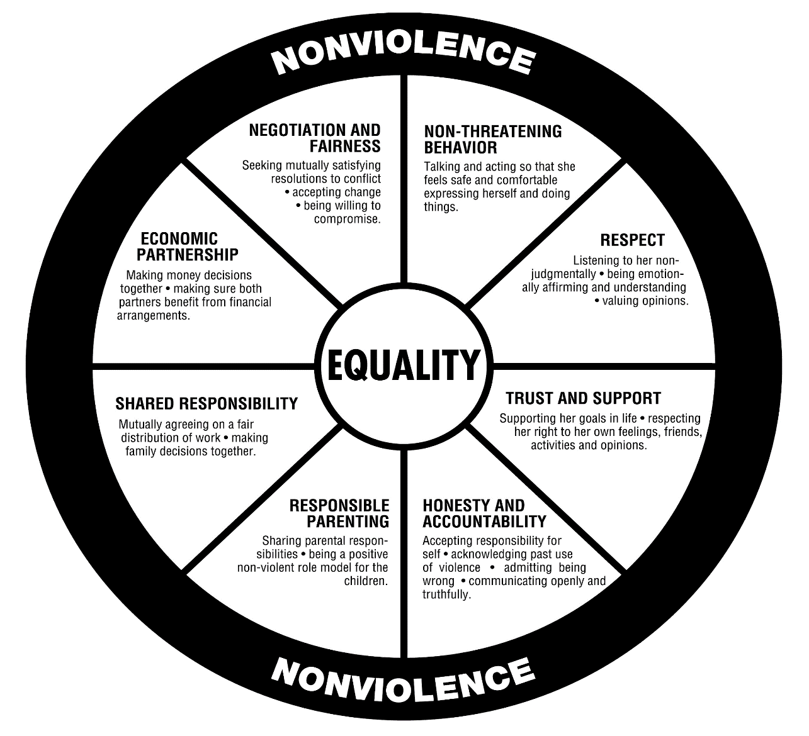

Healthy relationships are characterized by economic partnership, negotiation and fairness, non-threatening behavior, respect, trust and support, honesty and accountability, modeling of good behavior, and shared responsibility. The GAL should determine the presence or absence of these traits.

Relationships and families fall somewhere on a continuum between these two extremes, being neither fully abusive nor fully equitable. The GAL must have an understanding of abuse, family dynamics, resources, and appropriate actions available to the GAL.

WHAT TO DO WHEN ABUSE IS SUSPECTED

A. Who must report?

- Certain categories of persons are required to report if they have reason to believe that a vulnerable adult has been or is likely to be abused, neglected or exploited. Those persons include but are not limited to physicians, nurses, mental health professionals, teachers, caregivers, staff or volunteers of an adult day care center or a facility, or law enforcement officers.
- Any other person who has actual knowledge of abuse, neglect, or exploitation.
- Any other person who has reason to believe that a vulnerable adult has been or may be abused, neglected, ro exploited may report.

B. When should a report be made?

A report should be made as quickly as possible. A person required to report must report within 24 hours or at least by the next working day. Failure to report is a crime. Professionals can also be subject to discipline by their licensing boards.

C. To whom should a report be made?

Determining to whom to report depends on where the vulnerable adult resides and the nature and severity of the suspected abuse.

- For adults living in a residential facility contracted with or operated by the Department of Mental Health (DMH) or the Department of Disabilities and Special Needs (DDSN), contact SLED.

SLED investigates allegations of criminal conduct involving vulnerable adults occurring in long term care facilities as well as allegations involving facilities operated by or contracted for operation by DDSN and DMH. SLED also refers reports of non-criminal problems, such as violations of residents’ rights, to the state’s Long Term Care Ombudsman, the Department of Social Services, or the Attorney General’s Medicaid Fraud Control Unit for investigation and further action.

SLED has a statewide toll-free number that is answered 24 hours a day, 7 days a week: 1-866-200-6066.

- For adults residing in other residential facilities, such as private nursing homes and most community residential care facilities, contact the SC Long Term Care Ombudsman’s Office at 1-800-868-9095. he Long Term Care Ombudsman’s Office investigates non-criminal allegations pertaining to maltreatment of vulnerable adults residing in facilities. For more information, visit:
http://www.state.sc.us/ltgov/aging/Seniors/Ombudsman.htm.

- For adults residing in private or foster homes, SC Department of Social Services (DSS), contact the county DSS office where the person resides. State DSS Adult Protective Services investigates non-criminal allegations of maltreatment of vulnerable adults which occur in community settings. The phone number is 803-898-7318. Local phone numbers can be found at www.state.sc.us/dss/counties.html.

- The Medicaid Fraud Unit of the S.C. Attorney General’s Office investigates embezzlement of patient funds by Medicaid providers as well as some abuse and neglect of patients in some facilities. If there is a misuse of Medicaid funds, including financial exploitation of a Medicaid recipient, contact the SC Attorney General’s Medicaid Fraud Control Unit at 1-888-662-4328.

- A complaint against a licensee, or an unlicensed person practicing a profession or occupation that requires a license (such as a Nursing Home Administrator or a Community Residential Care Administrator), may be made online using the South Carolina Department of Labor, Licensing, and Regulation’s online complaint form (https://eservice.llr.sc.gov/Complaints/).

- Local law enforcement investigates allegations of criminal conduct occurring in private and community settings. For local law enforcement, check your local phone listings.

- In an emergency, call (911), and the dispatcher will direct you to the appropriate authority.

In addition to this immediate reporting, a GAL has a duty to file a motion in the probate court “for any necessary temporary relief to protect the alleged incapacitated individual from abuse, neglect, abandonment, or exploitation, or to address other emergency needs of the alleged incapacitated individual.” The GAL should request the appointment of counsel, by contacting the court in writing, to file the motion and other required pleadings.

S.C. Code Ann. § 43-35-10.
The U.S. Centers for Disease Control defines elder abuse. See: https://www.cdc.gov/violenceprevention/elderabuse/definitions.html.
The National Center on Elder Abuse, housed in the U.S. Office on Aging. See: http://www.ncall.us/defining-abuse-in-later-life-and-elder-abuse/
The “Elder Justice Roadmap” published by the National Center on Elder Abuse (with funding provided by the U.S. Department of Justice). See: https://www.justice.gov/file/852851/download.
The World Health Organization. See: http://www.who.int/ageing/projects/elder_abuse/en/.
For more information, you may wish to read the S.C. Omnibus Adult Protection Act, S.C. Code Ann. § 43-35-10, et seq.
https://www.theduluthmodel.org/wheels/
S.C. Code Ann. § 43-35-25.
S.C. Code Ann. § 62-5-106(A)(7). More information on temporary relief is provided in Chapter 5 of this Manual.

