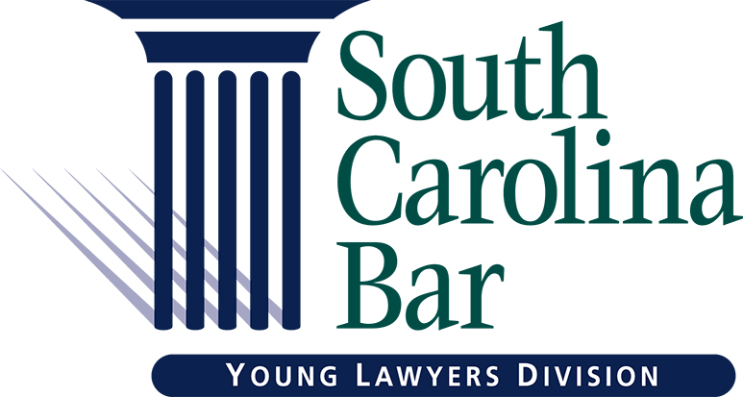

Young Lawyer Division Circuit Event Proposal

Circuit Information
Circuit(s): _______________
Contact Name:
Phone/E-mail:
Event Specifics
Event Title:
Purpose of Event:
Location:
Date: _______ Time: _______
Estimated Attendance: _______
Event Budget
Total Cost: _______
Food: _______
Beverage: _______
Venue: _______
_______ Pay vendor(s) directly prior to event _______ Request for reimbursement after event
All check requests must include supporting documents for the funds being used.
Event Partnerships
Please list any legal organizations working with the YLD Membership Committee to co-sponsor your event:

